
Volume XX, Issue X (202X) xxx-xxx
E-ISSN: XXXX-XXXX

Research Article
Times New Roman, 12 point, centered, bold
Auther Name SURNAME¹
¹XXXX University, Faculty of XXXX, City, Country

ABSTRACT

The abstract should not exceed 250 words.
Aim: The text should be written in Times New Roman font, 10 point size, single line spacing.
Methods: The text should be written in Times New Roman font, 10 point size, single line spacing.
Results: The text should be written in Times New Roman font, 10 point size, single line spacing.
Conclusion: The text should be written in Times New Roman font, 10 point size, single line spacing.

Keywords: Disease, Exercise, Health, Movement, Treatment. (minimum 3 words, maximum 5 words)

ARTICLE METADATA
Received: XX.XX.202X
Accepted: XX.XX.202X
Published: XX.XX.202X

Corresponding
Author Name SURNAME
XXXX University, Faculty of XXXX, City, Country

- Headlines are in bold, Times New Roman font, 12-point size, 1.5 line spacing, left-aligned.
INTRODUCTION
The text should be formatted in Times New Roman font, 12-point size, 1.5 line spacing, and a 1 cm indentation.
METHODS
The text should be formatted in Times New Roman font, 12-point size, 1.5 line spacing, and a 1 cm indentation.
RESULTS
The text should be formatted in Times New Roman font, 12-point size, 1.5 line spacing, and a 1 cm indentation. Findings should be presented clearly and concisely, using tables or figures where appropriate. The same data should not be repeated in both table and figure formats. Where appropriate, effect sizes and their confidence intervals should be reported along with p-values. P-values ​​greater than .01 should be reported with two decimal places, values ​​between .01 and .001 with three decimal places, and values ​​below .001 should be expressed as p < .001. Always use zero at the beginning of decimal numbers (e.g., .05), and report exact p-values ​​instead of threshold expressions whenever possible.

Example Figure
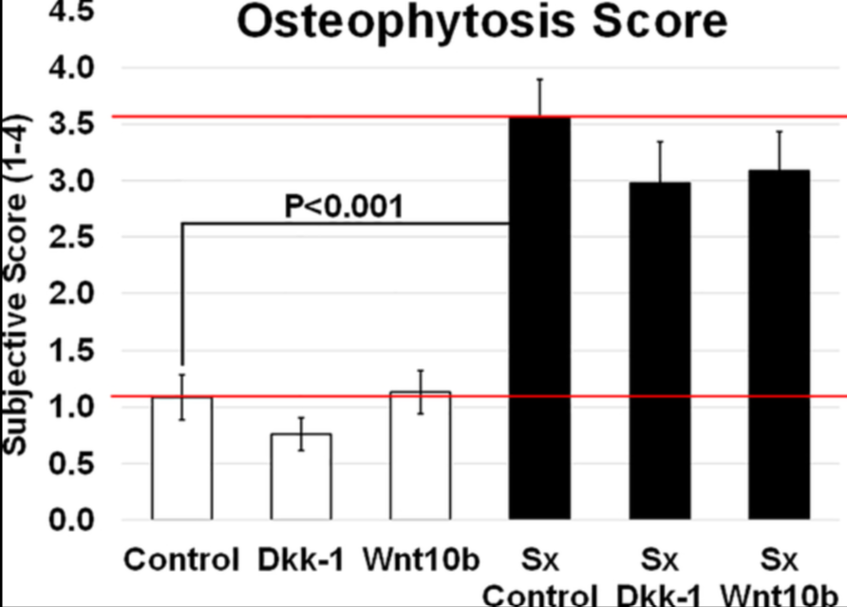
(Mason et al., 2017).
Figure 1: The title should be in bold, while the text should be in standard 10-point font, with single line spacing at the top and zero line spacing at the bottom.

Example Table

Table 1. Table text should be 10-point font, table titles should be bold, the first letter of each word in the table title should be capitalized, and there should be one space after the table title (1 line spacing, 10-point; 0 pt before and after).

Parameters | Control group (n=40) | Patient group (n=40) | Test statistics | p
Age (years) | 51.28 ± 6.14 | 58.47 ± 7.91 | Z = −3.214 | <.001
Sex (F/M) (%) | 23/17 (57.5%/42.5%) | 26/14 (65.0%/35.0%) | χ² = 0.472 | >.05
BMI (kg/m²) | 27.13 ± 3.42 | 28.04 ± 3.18 | t = −1.228 | >.05
F: Female, M: Male, BMI: Body Mass Index. t: Student t-test, Z: Mann-Whitney U test, χ²: Pearson chi-square test.
DISCUSSION
The text should be formatted in Times New Roman font, 12 point size, 1.5 line spacing, and a 1 cm indentation.

CONCLUSION
The text should be formatted in Times New Roman font, 12 point size, 1.5 line spacing, and a 1 cm indentation.

REFERENCES (Times New Roman font, 10 point, bold, 1 line spacing, 0 points before and 10 points after.)

1. Çetin, Y. (2025). Creative Use of Pecha Kucha Presentation Technique in Providing Crisis Management Skills to Nurse Managers. Disaster Medicine and Public Health Preparedness, 19, e174. https://doi.org/10.1017/dmp.2025.10099
2. Agrali, C., Unal, E., Kapikiran, G., & Cetin, Y. (2024). The Effect of Compassion Fatigue on Empathic Anger Levels in Nurses, 11(1), 171-180. https://dx.doi.org/10.54304/SHYD.2024.01488
3. Erol, E., Burak, M., & Elbasan, B. (2025). Effects of instrument-assisted manipulation and mobilization with movement in chronic non-specific low back pain: A randomized controlled trial. Journal of Back and Musculoskeletal Rehabilitation, 38(3), 640-650. https://doi.org/10.1177/10538127241309343
4. Beydagi, M. G., Bağdatli, S. B., Topal, Y., Kinikli, G. I., Huri, G., & Güney-Deniz, H. (2026). Improvements in hip stability and knee muscle strength after a single-dose platelet-rich plasma injection combined with exercise in women with knee osteoarthritis. Irish Journal of Medical Science (1971-), 1-9. https://doi.org/10.1007/s11845-026-04390-3
5. Çankaya, A., Özsoy, H., Gülşen, M., & van Giersbergen, M. Y. (2025). A Critical Threat to Patient Safety: A Bibliometric Analysis of Wrong-site, Wrong-side, and Wrong-organ Surgery. Journal of Patient Safety, 10-1097. https://doi.org/10.1097/pts.0000000000001457
6. Danis, E. G., Acar, G., Dasdelen, D., Solmaz, M., Mogulkoc, R., & Baltaci, A. K. (2024). Naringin affects Caspase-3, IL-1β, and HIF-1α levels in experimental kidney ischemia-reperfusion in rats. Current Pharmaceutical Design, 30(42), 3339-3349. https://doi.org/10.2174/0113816128324562240816095551
7. Miles, M. B. and Huberman, A. M. (1994). Qualitative data analysis: An expanded sourcebook. Sage Publications.* References should be prepared according to APA 7th edition writing guidelines ( DOI number must be included).

Ethics Committee Approval
XXXXX University Clinical Research Ethics Committee (Date: XX.XX.202X, Decision No: XXXX).
Informed Consent
XXXXX
Funding
The authors declared that this study received no financial support.
Acknowledgements
The text should be formatted in Times New Roman font, 12-point size, 1.5 line spacing, and a 1 cm indentation.
Supporting Material
The text should be formatted in Times New Roman font, 12-point size, 1.5 line spacing, and a 1 cm indentation.

